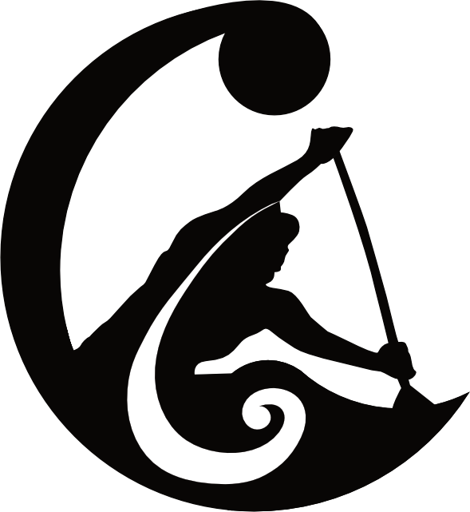

Presenting The 6th Annual
Cathedral Cove Challenge

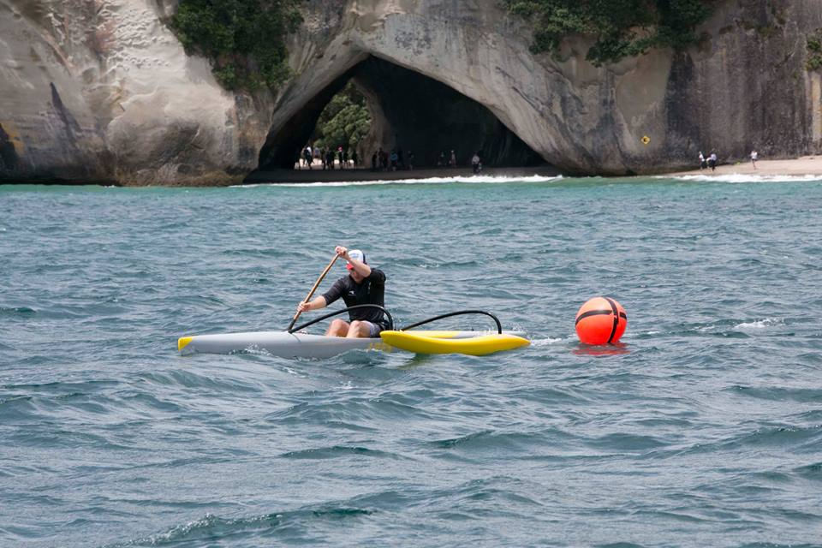

7-8th October 2023

23-24km W6 Saturday
16km W1 & W2 Sunday
Hosted by: Whitianga Waka Ama
Venue: Buffalo Beach Reserve, Whitianga

Event Details
- Saturday W6 races: 23-24 km
- Sunday W1 & W2 race: 15-16 km
Hosted by: Whitianga Waka Ama Club
Venue: Buffalo Beach Reserve, Whitianga

DAY 1 - SATURDAY 7th OCTOBER 2023

WAKA DROP OFF:
- Race 1: ensure you arrive between 7am-9am to unload waka and park trailers.
- For race 2 ensure you arrive between 10.30am-12.30pm to unload waka and park trailers. Space is limited.

Divisions:
23-24km - W6 - Women, Mixed, Men
$390 per team (includes race entry, entry to evening prize giving and a sit down meal for each paddler)

Day 1 Prizegiving - Saturday 7th October, 2023

Time: 5.30pm @ the Whitianga Bowling Club, 92 Cook Drive, Whitianga
Trophies and spot prizes from our generous sponsors will be awarded on the night.
You must be present at the prize giving to claim spot prizes.

Included: Team entry fee into the 23-24 km race includes tickets for paddlers to the prize giving and dinner on Saturday night. There will be a bar onsite, open from 5.00pm.

Prize Giving Dinner: Additional tickets may be able to be purchased for $30 per person depending on numbers. For catering numbers please advise of any additional tickets prior to Tuesday 26th September. Vegetarian option available. Enquiries to wakawhiti@gmail.com

Please note: Tickets to the prize giving dinner on Saturday night are not included with the entry costs of the W1/W2 races on Sunday.

DAY 2 - SUNDAY 8th OCTOBER, 2023

Divisions:
15-16km - W1/W2 – Women, Mixed, Men
$30 per paddler

Day 2 Prize Giving - Sunday 8th October, 2023

Time: After finish of the last race @ Buffalo Beach Reserve
Trophies, certificates and spot prizes from our generous sponsors will be awarded on the beach at the conclusion of the final race.
You must be present at the prize giving to claim spot prizes

Event Schedule:
Saturday 7th October, 2023

8:45am Registration
9:25am Karakia
9:30am Race 1 briefing - W6 Women & Mixed
10:00am Race 1 start

1:00pm Race 2 briefing - W6 Men
1:30pm Race 2 start
5.00pm Bar and Venue open (Whitianga Bowling Club)
5.30pm Prize Giving
6:30pm Dinner

Event Schedule:
Sunday 8th October, 2023

8:30am Registration
8:55am Karakia
9:00am Race 3 briefing - W1 / W2
9:30am Race 3 start
11:30am Prize giving

How to enter
Your club Rep must enter you on the Waka Ama website:
XXXX
Contact: wakawhiti@gmail.com

Once entry is in please make payment to:
Whitianga Waka Ama 02 0496 0127653 000

Please use your team name, race number and division as a reference.

Extra Information

Soup & sausage will be made available to all paddlers after their event.

There will be a number of spot prizes drawn at both prize givings.
Paddlers must be in attendance to qualify for spot prizes!

Trophies will be awarded and all divisions will receive certificates for placing 1st, 2nd or 3rd.

Follow us on Facebook for event updates: https://www.facebook.com/whitiangawakaama

https://www.facebook.com/CathedralCoveChallenge

Course Information: Saturday Race 1&2
23-25km Race Course - W6 Women / Mixed / Men

Preferred COURSE A: 25km. Note course may be altered if conditions require.

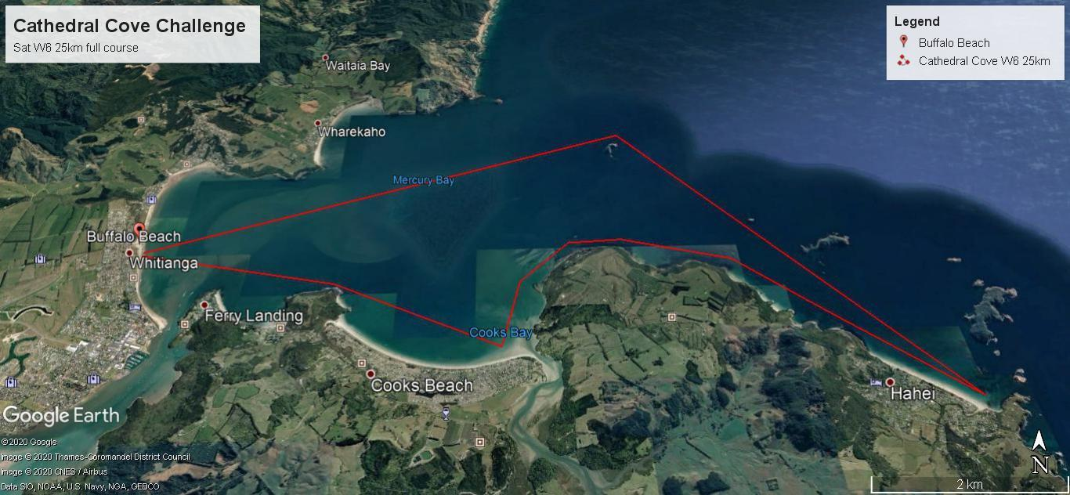

COMPULSORY EQUIPMENT:

The following equipment must be carried by all W6 waka and will be signed-off at safety checks:
- 1 life jacket/PFD per paddler (must fit correctly)
- 2 bailers
- 2 Spare paddles
- 25m Tow rope
- Spray skirts may be compulsory TBC on the day.

And at least one of the following items:
- Waterproof Cell phone or in a waterproof bag
- VHF Radio
- Daytime distress flare

Alternative COURSE B: 23.48km
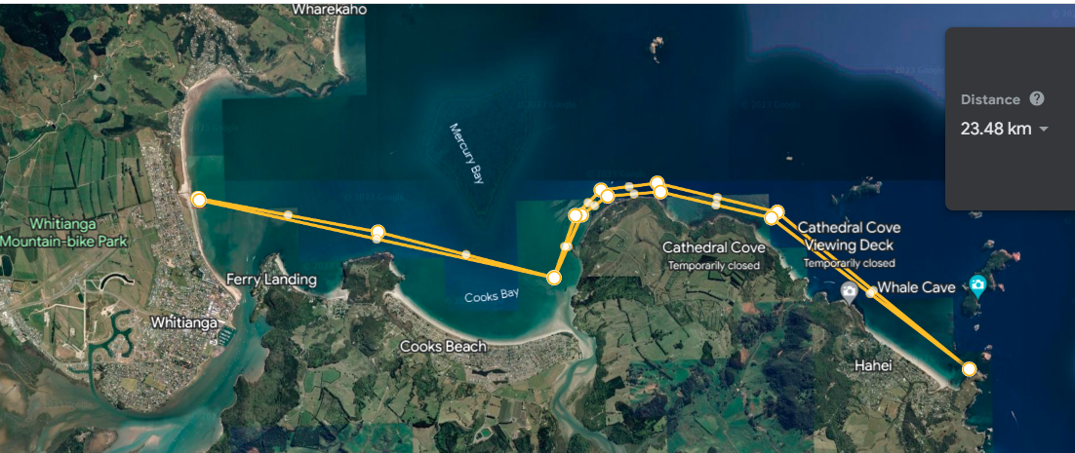

Alternative COURSE C: 8km loop x 3 laps
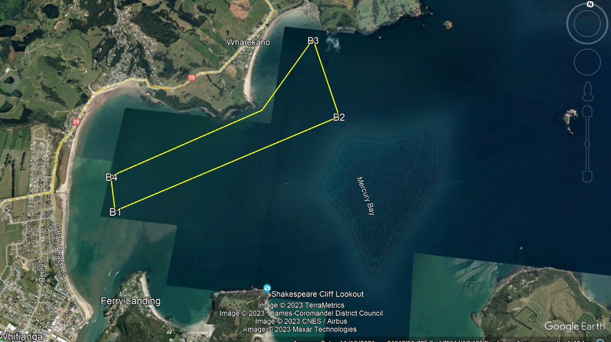

Course Information: Sunday Race 3
16km Race Course - W1 & W2

Preferred COURSE A: 16km. Note course may be altered if conditions require.
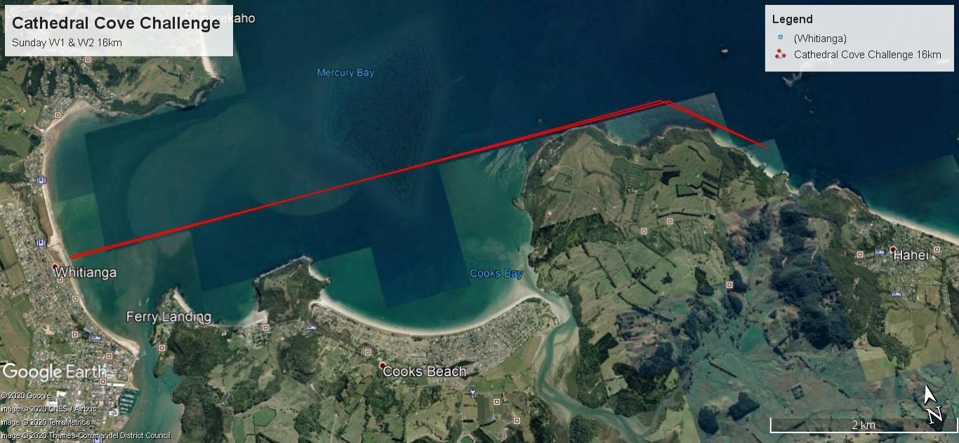

Compulsory Equipment:

The following equipment must be carried by all W6 waka and will be signed-off at safety checks

- 1 life jacket/PFD per paddler (must fit correctly)
- 1 bailer (unless self draining)
- leg leash for sit on top W1
- 1 spare paddle W1,W2
- high visibility item (i.e hat/shirt)

And at least one of the following items:
- Cell phone in waterproof bag
- VHF Radio
- Daytime distress flare

Alternative COURSE B: 8km loop x 2 laps

